PROJECT PSYCHIC ADVENTURE DESIGN LOG

JAN – 28/1/2020 – Tuesday – Dropping Cash

Just thought of a way to lure NPC’s to where you want them to go.
You could drop your money on the ground which can become a collectable item, Npc’s could see it and move towards it to pick it up. You could leave a trail of money which will lead them to certain places.
Could also use telekinesis on the money to mess around with them.
I believe there should be a check between npc type and the value of the money found and only be lured if the amount is worth its while, to prevent the player being able to lure npc’s with only 1£ coins.

Criminals and muggers will leave you alone if you present a decent sum of money on the ground.

JAN – 27/1/2020 – Monday – Gameplay Diagram

Designed a diagram which sums up what the player can generally do in its loop.

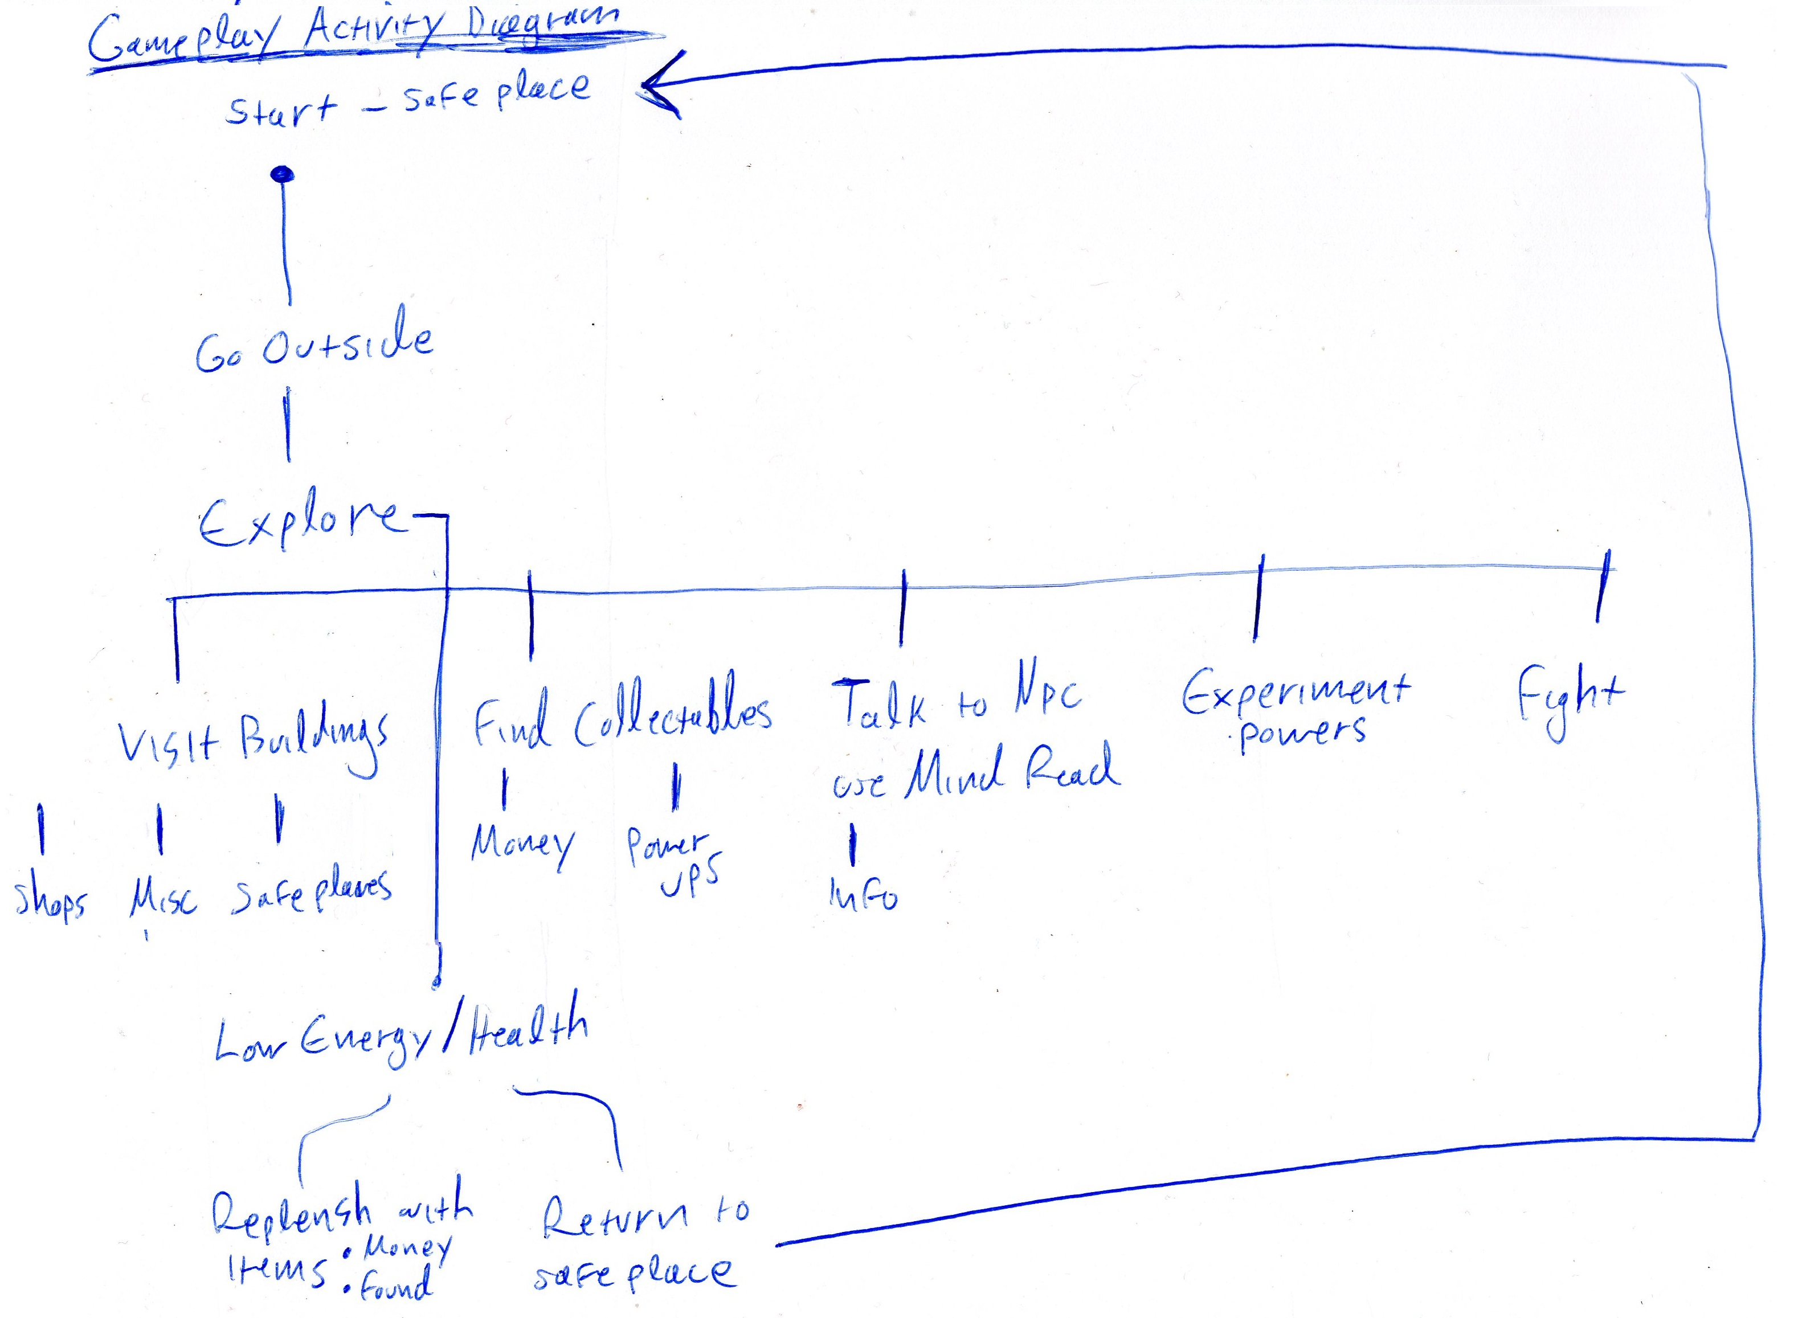
If the player lose all his health he’ll start at the last safeplace.

JAN – 24/1/2020 – Friday – Ecosystem

Thought on an idea of having an ecosystem in play which can be manipulated by the player in certain ways.

There are 4 factions: Police, Citizens, Criminals and Aliens.

Police Protects Citizens and repels Criminals.
Citizens repel Aliens.
Criminals prey on Citizens and fear Police.
Aliens avoid Citizens, don’t care about Criminals and slightly avoid Police.

When one faction numbers reduce another increases.

Aliens can modify the ecosystem if they’re getting overpowered/underpowered.

Too many aliens or criminals can make the game harder while too many citizens & police can make the game easier.
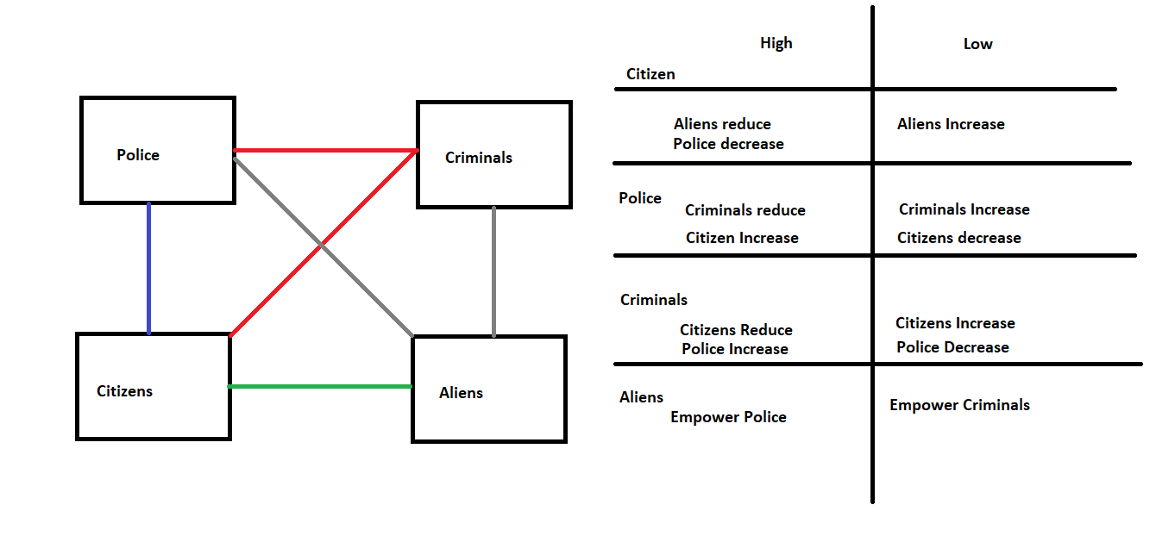

JAN – 23/1/2020 – Thursday – Read Minds Log

As of now npc’s are a fixed amount and persistent.

Reading their minds access information about it.

I’ve had an idea that for every mind the player reads it enters into a log where he can read them in detail at their leisure.

Being able to read each npc’s bio & schedules makes it easy to plan out actions, especially when the number of npc’s grow.

JAN – 23/1/2020 – Thursday – Limits for Very Powerful Powers

The ammo system was useful for powers that might be too strong to be used casually like Teleport and Fear.

In the last post I wrote about using a universal energy gauge for all powers instead of having individual points for each power. Making those powers have a high energy cost will inconvenience the player by not being able to use as many regular powers, forcing him to rely on consumables or to retreat and rest.

I can either have those powers to require ammo OR put them on a long cooldown.

JAN – 22/1/2020 – Wednesday – Energy vs Individual Ammo for Powers

Thinking whether to use a generic energy gauge like mana for magic or to keep it as an individual ammo point for each power.

The benefits of using Energy is that it simplifies the systems, to use powers I would need energy that can be converted into powers, it could be 10 telekinesis and 2 teleports or 30 shots and 2 telekinesis.

The benefits of using ammo is that for each power I know exactly how many times I can use each spell, for example: I can always do 10 telekinesis and only 2 teleports.

I'm thinking that the ammo system might be a bit cumbersome as if I run out of a certain power when needed I can get stuck or have to leave and rest to replenish. I would also need ammo for each individual power which would make the powers feel like guns.
Having a system that can convert generic ammo into specific ammo for a power already feels like it overcomplicates things.

Energy: 1 – Ammo: 0

JAN – 17/1/2020 – FRIDAY – Human Manipulation

The player have several powers that can be used on the Humans in town which includes accessing hidden information (Enter Mind), temporarily taking control of their actions (Mind Control) and altering their mental state (Fear, Berserk).

The core concept of this project is using these powers to progress and I think using the NPC’s with their persistency and routines would make for some interesting challenges and puzzles.

For example you could have a dungeon where you’re in a building full of people where you need clearance to get to your goal but you require things like passwords and a written letter with some orders from a supervisor in order to achieve that goal. Manipulating people around you, learning about the habits and schedules of each in order to achieve a goal.

JAN – 14/1/2020 – TUESDAY – Locked Districts

Thinking of having the town separated into several districts which are closed off from one another with few exceptions.
One of your main activities is to get into one district to the next.

JAN – 14/1/2020 – TUESDAY – Main loop

So far the core loop of this game is:

Go to Town → Explore → Energy depleted → Rest and repeat

Explore can include interacting with NPC’s, using your powers, discovering new areas and fighting, eventually your energy will eventually deplete of psychic power points so you’ll need to find a place to rest.

Resting Heals your health and restores energy and psychic power in addition to saving your game, however your time is skipped, changing the game’s state.

When it’s day time there are open shops, plenty of npc’s and limited hostiles. At night the shops are closed, limited npc’s are available and hostiles are plentifull.

JAN – 14/1/2020 – TUESDAY – Setting

Last time I’ve decided to take the Alien route instead of Demons because I’ve found them rather hard to design around particularly them being non-corporeal beings and require hosts, Aliens on the other hand are corporeal.

I’m thinking the setting should take place in a small town located far far away from civilization, cell signal is limited or non existent and noone in town owns a vehicle making it impossible to leave this place by foot. It could be located either on a mountain or surrounded by several mountains making it dangerous to attempt to escape by foot.

Maybe a bridge which can prevent you from leaving.

JAN – 10/1/2020 – FRIDAY – First Entry

Trying a new format of writing down design decisions and thoughts. As of now the game starts at a prototype house which you can leave to the prototype city, it is dark outside as the hour is very early in the morning.
At one section there’s the demon possessing citizen experiment which transforms and starts shooting at you when you approach it, using the psy shot power hurts it, after two hits it tries to flee but is trapped in a dead end and doesn’t know which way is the exit, after the third hit it transforms back into a human and the demon “soul” is ready to be picked up.
Using telekinesis I can move rocks by using the mouse and can throw it in any direction. I can also use it on light switches and on the NPC who is waiting to go to work, the power has 10 uses.
The Psy Shield can protect you from projectiles and flinches enemies on contact as seen in a previous scene, now has use of 50 which depletes 1 for every seconds is up.
The Enter Mind spell puts me in a reach the goal without getting hit minigame which opens up an “atari 80s inspired” dungeon which contains object that holds NPC’s information and
thoughts.
Psyshot shoots in the direction of the mouse and has 30 units of ammo and serves as the primary way of hurting enemies. In the previous scene it has the ability to bounce of glass.
Last power is not yet attached to the player but can set it off in the editor, the Fear power.
Fears NPC in a cone, when feared the npc will run away as fast as it can.
Last aspect is the NPC’s schedule, when the time reaches 07:00 it will make way to its shop and open up the Shop Interface object which when interacted you can see whats for sale. If you interrupt it with fear or telekinesis it will go back to its station if is within working hours. At around 16:00 it will close shop and head home until the next day.
It has some pretty cool aspects but lacks a definite gameplay loop. Still in a very primitive state.
The concept at the moment revolves around fighting demons as seen in the possessed citizen example but I’m thinking of moving away from that to fighting aliens instead.
The psy ammo makes your powers more valuable but I need ways of replenishing them and maybe something like a punch so you’re not crippled when facing a combat situation if your powers run out.
CONCEPT

Build a game about where the player utilizes psychic abilities in a town where day and night come to pass and NPC’s have schedules.

